# Broken Petrol Ltd - Petrol station management app

## Application synopsis

This application will help highlight the benefits of the efficient usage of the petrol station forecourt in driving up profits. The application will highlight that having a pump attendant to direct traffic to the most suitable pump will increase sales, revenues and profits. The application produces reports to allow you to analyse the transactional sales figures.

The writers of the petrol station management system are sure you will never regret purchasing this money-making application as you see your revenue and profit soar.

## Running the app

You can tun the application by double clicking on the **.exe** file called **Assignment_2_PetrolStation_HighLevel.exe.**

You can stop the application running so that you can analyse the data by pressing **Esc.** Please note that currently the application will not start again after. This functionality is intended for commercial release rather than beta demo-ing. Presses **Esc** also produces two reports that can be opened in Excel for analysis. See the section below Reading the Reports.

To close the application, click the **X** in the top right of the console screen.

## Understanding the user interface

After running the application, you will see a screen similar to the one below.

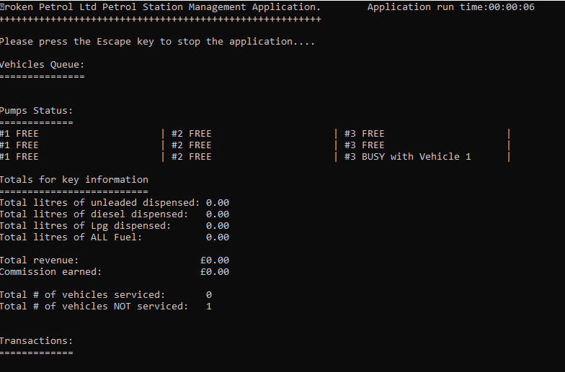

**Title and user instructions**

At the top of the display you will see application title – that briefly states what the application does and who it is developed for. Below the title is a user prompt to tell you that you can stop the application running by pressing the Esc key on your keyboard. There is also a timer in the top right. This is useful for giving the user a realistic time frame for the data they are seeing.



**Vehicle Queue**

Below this prompt you will see data for the vehicle queue information. This shows what vehicle are currently queuing and have not yet been assigned to a pump. The display shows the vehicle Id, the vehicle type, the type of fuel the vehicle uses.

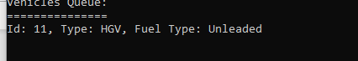

**Pump status**

The pumps status section shows the nine pumps in three rows of three as they might appear in a petrol station forecourt. You can see the pump number and whether it is free or busy. If a pump is busy the vehicle fuelling at the pump is also displayed. Vehicles are not allowed to ‘jump the queue’. This means that if the first pump in each row is busy then a vehicle in the queue cannot access either the second or third pump in that row. Similarly, if the second pump in the row is busy the next vehicle in the queue cannot access the third pump in the row.

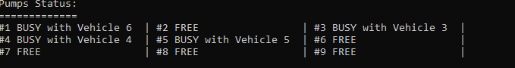

**Key statistics**

The next section shows totals for certain key statistics.

1. The total number of litres dispensed or sold whilst the application is running for unleaded petrol.
2. The total number of litres dispensed or sold whilst the application is running for diesel.
3. The total number of litres dispensed or sold whilst the application is running for LPG.
4. The total number of litres dispensed or sold whilst the application is running for ALL fuel.
5. The total revenue earned at the petrol station whilst the application is running.
6. The 1% commission earned by the attendant.
7. The number of vehicles successfully serviced at the station, i.e. vehicle which fuelled.
8. The number of vehicles NOT serviced at the station i.e. vehicle which left the forecourt before being servicing.

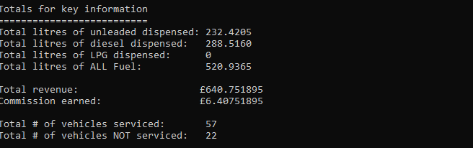

**Transactions**

This section of the display shows a list of the successful transactions carried out at the petrol station.

The details include a unique transaction ID, the vehicle type and Id, the number of litres sold, the pump number, the fuel type, the fuel capacity, initial fuel level and the fuelling time.

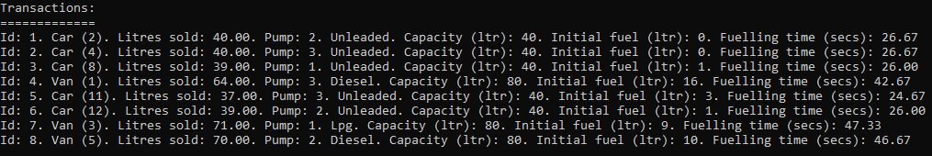

## Reading the reports

The reports contain the same information that you will see on the display. The advantages being it is easy to perform analysis on the data. In this demo version of the software two separate work books are opened. However in the first commercial release of the application these will be combined and the reporting enhanced. Two sample reports have been included the applications folder (**PetrolStationTotalsReport2019-12-10_11-41-48.csv** and **PetrolStationTransactionsReport2019-12-10_11-41-48.csv**)